🔍 𝗥𝗮𝗯𝗯𝗶𝘁𝗠𝗤 𝘃𝘀. 𝗞𝗮𝗳𝗸𝗮 𝘃𝘀. 𝗔𝗰𝘁𝗶𝘃𝗲𝗠𝗤 🔍

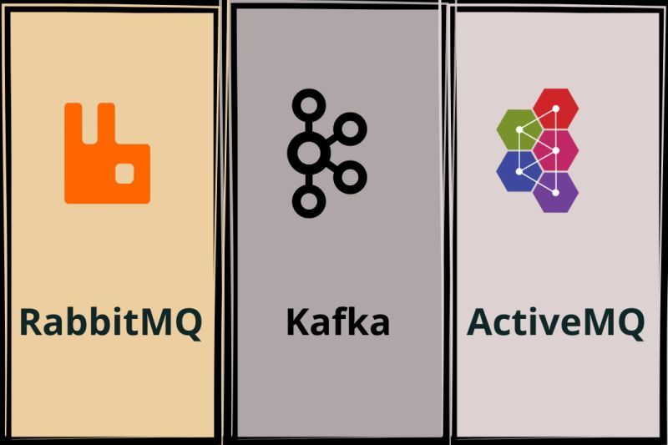  
  
🔹Performance and Scalability:  
  
- RabbitMQ: Excels in small-scale systems where low latency is paramount.  
- Kafka: Designed for large-scale, high-throughput systems, often outperforming others in this context.  
- ActiveMQ: Good all-rounder, but may lag behind Kafka in high-throughput scenarios.  
  
🔹Message Priority:  
  
- RabbitMQ: Supports message prioritization.  
- Kafka: No inherent message priority; order is maintained by timestamp.  
- ActiveMQ: Offers message priority handling.  
  
🔹 Durability:  
  
- RabbitMQ: Messages can be made durable, surviving broker restarts.  
- Kafka: High durability due to its distributed nature and replication factor.  
- ActiveMQ: Supports durable messages, but durability can impact performance.  
  
🔹 Message Model:  
  
- RabbitMQ: More flexible with multiple exchange types.  
- Kafka: Primarily a publish-subscribe model.  
- ActiveMQ: Supports both point-to-point and publish-subscribe models.  
  
🔹 Replication:  
  
- RabbitMQ: Basic replication, manual failover.  
- Kafka: Replication built-in, with automatic failover.  
- ActiveMQ: Supports replication, but configuration can be complex.  
  
🔹 Stream Processing:  
  
- RabbitMQ: Not designed for stream processing.  
- Kafka: Built-in stream processing capabilities.  
- ActiveMQ: No native support for stream processing.  
  
🔹 Availability:  
- RabbitMQ: High availability through clustering and mirroring.  
- Kafka: High availability due to its distributed nature.  
- ActiveMQ: High availability through active/passive configuration.  
  
📚 As software and DevOps engineers, understanding these nuances helps us make informed decisions in designing resilient, scalable, and efficient systems. Remember, it's not about choosing the "best" technology, but the right one for your specific use case.